KRT18 and KRT 19 Staining of DU145 Prostate Cancer Cell

Control: Fixed cells were incubated with only a mixture of anti-mouse and anti-rabbit fluorescent secondary antibodies to ensure there is no specific staining. Which none was seen.
Experimental wells: Fixed cells were stained with both KRT19 and KRT 18. The co-localization of KRT18 with KRT19 indicates the cancer nature of the cells.
Procedure: Cells are plated in multi-well chamber slides fixed with 4% paraformaldehyde (10 min at room temperature), rinsed with PBS. Fixed cells were incubated with diluted primary antibodies (KRT18 - MAB12104 from Thermofisher, 1:300 and KRT19 – 14965-1AP from Thermofisher, 1:500; antibodies diluted with Antibody Dilution Buffer for ICC and IHC, SF40010) for 2 hours at room temperature, rinsed 3 times 15 min each in PBS pH7.4. Then incubated with fluorescent secondary antibodies (anti-mouse Cy2 and anti-rabbit Cy3 from Jackson ImmunoResearch) for 30 minutes at room temp., washed in PBS same as above and mounted using iBright medium (SF40000).
Control Well 1 | Control Well 2
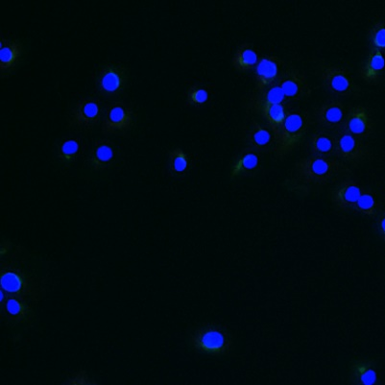 | 